ROUGH DRAFT

Title:

Propensity-weighted prognostic associations of hypercapnia by Arterial and Venous Blood Gas: A retrospective, multicenter health records study

Authors:

Anila Mehta MD¹, Jeanette P. Brown MD, PhD², Ramkiran Gouripeddi MBBS MSc³, Ithan Peltan⁴, Brian W. Locke MD, MSc⁴

¹University of Utah Internal Medicine Residency
² Division of Pulmonary, Critical Care, and Occupational Pulmonary Medicine, University of Utah
³Department of Biomedical Informatics, University of Utah
⁴Department of Pulmonary and Critical Care, Intermountain Medical Center.

Conflicts of Interest:

B.W.L. equity interest with Mountain Biometrics, a medical AI startup.

Author Contributions:

Data/Code Availability Statements:

Statistical code is available at https://github.com/reblocke/abg-vbg-project
Individual patient data is from TriNetX and is accessed under a data use agreement and cannot be shared.

Abstract: [ ] TODO last

Background:

Methods:

Results:

Conclusions:

Introduction:

Hypercapnia results from lungs’ inability to adequately remove carbon dioxide from the bloodstream, leading to its accumulation Arterial blood gases (ABGs) are the gold standard for assessing acid-base balance, oxygenation and ventilation status, and remain essential in the management of hypercapnic respiratory failure. However, arterial sampling is uncomfortable for patients, time-consuming, and technically challenging. Potential complications from ABGs include arterial injury, thrombosis, air or clotted blood embolism, arterial occlusion, hematoma, and aneurysm formation. ¹

Because venous sampling is routine, VBGs may offer a simpler and more patient-centered alternative to ABGs, though their value hinges on whether they carry comparable diagnostic and prognostic information. On ABG, hypercapnia is defined as greater than 45 mmHg while on VBG, hypercapnia is usually defined as greater than 50 mmHg. VBGs are increasingly being used as a screening tool for hypercapnia due to ease of collection and reduced risk, though they are less precise in measuring arterial pCO₂ compared with ABGs.

Despite their growing use, there has been limited studies comparing VBG versus ABG in diagnosis of hypercapnic respiratory failure, and billing and device qualification guidance does not admit venous blood gas as sufficient evidence of hypercapnic respiratory failure. In a study by Davies et. al, hospitalized patients with known or suspected hypercapnic respiratory failure underwent near-simultaneous ABG and VBG testing. Results demonstrated close agreement in PaCO₂ values between ABG and calculated values derived from VBGs, supporting the use of VBGs in monitoring hypercapnic patients.² Similarly, a review by Lacy et. al analyzed a prospective study which found VBG to have 100% sensitivity in identifying hypercapnia in those with respiratory failure due to COPD exacerbation, pneumonia, heart failure and asthma using PvCO₂ greater than 45 mmHg.¹ Ak et. al published an additional prospective study in COPD patients in acute exacerbation that found VBG to identify hypercapnia in 100%. ³ In contrast, McKeever found wide variability between arterial and venous CO₂ levels in COPD patients with acute exacerbations, underscoring the limitations of VBG precision.⁴ Most prior studies have emphasized the analytical agreement between venous and arterial blood gases. Few have examined whether hypercapnia identified by each method carries similar prognostic weight, or whether observed differences reflect patient selection rather than biology. If venous hypercapnia predicts outcomes adverse outcomes such as the need for ventilatory support, this would support using VBGs as diagnostic evidence of hypercapnic respiratory failure.
Comparisons between ABG and VBG have often emphasized measurement agreement or categorical concordance. While such analyses are important to assess interchangeability, they assess only the analytic dimension of validity. Clinical utility, however, ultimately depends on prognostic relevance – how well each measure aligns with patient-centered outcomes. Analytic discordance alone does not indicate inferiority if prognostic performance is preserved. Our study focused on evaluating prognostic associations rather than measurement agreement alone.
We therefore examined whether hypercapnia by ABG and VBG predicts clinical outcomes in similar ways. Aftwer weighting for the propensity to receive each test, we compared their associations with diagnosis code for hypercapnic respiratory failure, receipt of invasive mechanical ventilation, receipt of non-invasive ventilation (NIV), and 60-day any-cause mortality. We hypothesized that venous and arterial hypercapnia would demonstrate similar associations with clinical outcomes, supporting VBGs as a viable alternative when ABGs are not performed.

Methods:

We conducted a multicenter retrospective cohort study using de-identified patent data from the 2022 TriNetX research network (TriNetX, LLC. Cambridge, MA), which aggregates electronic health record data from participating health systems. At the time of data requisition, the network included 76 medical centers across the US serving roughly 115 million patients. The University of Utah Institutional Review Board reviewed the study protocol and determined the project met criteria for exemption (IRB #00184622).

Study Population

Adult patients (≥ 18 years) were eligible if they had evidence suggesting possible hypercapnia during an emergency department or inpatient encounter between January 1 and December 31, 2022. We operationalized “reasonable suspicion for hypercapnia” using prespecified codes and laboratory indicators (e-Appendix 4), including (1) an arterial or venous blood gas obtained on the first hospital day; (2) diagnostic codes for respiratory failure or severe obesity; or (3) procedure codes for invasive or non-invasive ventilatory support. Ambulatory encounters were excluded. Patients with missing key demographic variables or outcome data were excluded. All phenotype definitions, including LOINC, ICD-10, and CPT/PCS codes used to identify eligible encounters, are provided in e-Appendix 4.

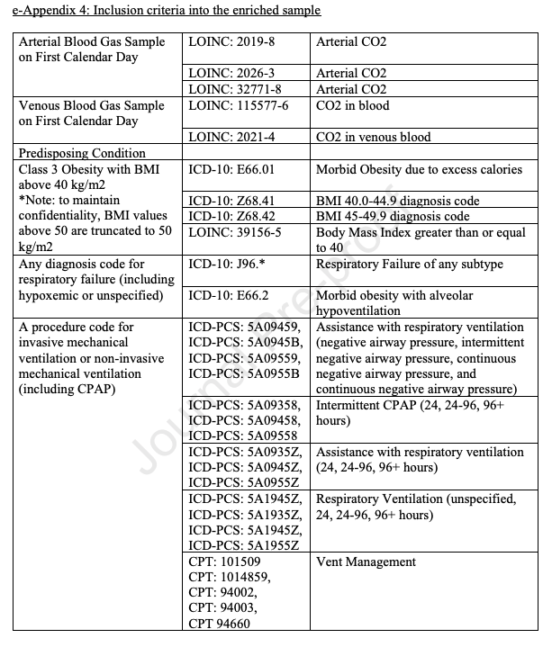

Exposure

Arterial and Venous blood gas measurements from the calendar day of the encounter start (day 0) were used to define the exposure.

Arterial samples were identified using LOINC codes 2019-8, 2026-3, and 32771-8 ); venous samples were identified using LOINC codes 115577-6 and 2021-4.

Outcomes
We evaluated four outcomes. (1) hypercapnic respiratory failure diagnosis during the encounter, identified using ICD-10-CM codes E66.2, J96.02, J96.12, J96.22, and J96.92. (2) r
eceipt of non-invasive ventilation at any time during the hospitalization as identified using ICD-10-PCS and CPT procedure codes, (3) r
eceipt of invasive mechanical ventilation at any time during the hospitalization, identified using ICD-10-PCS and CPT codes, and (4)
all-cause mortality within 60 days of encounter start. The 60-day window was selected based on ARDS literature, where this time point captures the greatest intervention-related mortality differences, reflecting the period when deaths attributable to respiratory failure and its management are most apparent.
Unadjusted Outcome Models
CO₂ was modeled in two forms. First, as a categorical variable: low (PaCO₂ <35 mmHg; PvCO₂ <40 mmHg), normal (PaCO₂ 35–45 mmHg; PvCO₂ 40–50 mmHg), and high (PaCO₂ ≥45 mmHg; PvCO₂ ≥50 mmHg). Second, we modeled CO2 as a continuous variable using restricted cubic splines with 4 knots, allowing flexible non-linear associations with outcomes. When multiple blood gas values were available on day 0, the initial measurement was used. All diagnostic and procedural code lists are provided in e-Appendix 4.
We first fit unadjusted logistic regression models to estimate the association between pCO₂ category (low, normal, high) and each of the four clinical outcomes. Odds ratios (ORs) with 95% confidence intervals were calculated using the normal pCO₂ group as the reference. Results were visualized using forest plots on a logarithmic scale, stratified by blood-gas cohort. We then modeled pCO₂ as a continuous predictor using restricted cubic splines to allow for non-linear associations. These models produced conditional predicted probabilities of each outcome across the full observed pCO₂ range, with 95% confidence intervals.
Inverse Probability of Sampling Weighting (IPSW)

To address differences in the types of patients who receive arterial versus venous blood gas sampling, we applied inverse probability of selection weights (IPSWs). This approach estimates each patient’s likelihood of receiving a blood gas based on observed covariates. Patients who were unlikely to be tested but nonetheless had a blood gas drawn are up-weighted, representing similar patients in the population who were not sampled.
Separate models were created to model propensity to receive ABG testing and propensity to receive VBG testing. After reweighting, patients in each testing cohort represent the same target population: all individuals meeting the hypercapnia-suspicion phenotype. This creates two pseudo-populations that approximate the same underlying source population and enables comparison of prognostic associations while reducing selection bias.
Propensity Score Model Specification and Diagnostics

Propensity scores were estimated using extreme gradient boosting machines (XGBoost), a supervised learning algorithm that flexibility accommodates non-linearities and missing data. Covariates included encounter type (emergency or inpatient), demographic variables (age, sex, race, ethnicity, BMI, location), comorbid conditions diagnosed on or before the index encounter (COPD, asthma, OSA, CHF, neuromuscular disorders, pulmonary hypertension, CKD, diabetes) and other objective data including triage vital signs and basic initial labs.
Weights were windsorized (truncated) at the 1st percentile to reduce the influence of extreme weights. Covariate balance was evaluated using standardized mean differences, with <0.1 indicating acceptable balance. Propensity score distributions were examined before and after weighting to evaluate overlap and support the positivity assumption.
Model Interpretability
We assessed variable influence using
both global feature importance and SHAP (Shapley additive explanations) analyses. Relative influence scores from the gradient-boosted model quantified each covariate’s contribution to overall model performance. SHAP values provided observation-level, signed estimates of how individual features shifted the predicted log-odds of receiving an ABG or VBG. Global SHAP summaries, calculated as the mean absolute SHAP value across the sample, characterized the typical magnitude and direction of each feature’s effect on selection.

Software: R version ***, using packages rms, weightit ***
Code is available at https://github.com/reblocke/abg-vbg-project

Results:

A total of *** patients met inclusion criteria for the study. Numbers excluded (missing key data, age <18, etc. see figure CONSORT.). Counts with any ABG, any VBG, both, and neither.

Describe major baseline characteristics (age, sex, BMI, race/ethnicity, comorbidities, encounter type) across: Overall cohort, ABG vs no ABG, VBG vs no VBG. Highlight clinically relevant differences (e.g., ABG patients more acutely ill, more NIV/IMV, etc.).

Within the ABG cohort: compare patients with vs without hypercapnia on ABG, Within the VBG cohort: compare patients with vs without hypercapnia on VBG. Emphasize whether hypercapnic patients appear sicker at baseline. Reference: Table 2. Characteristics by hypercapnia status within ABG and VBG cohorts (can stay largely as already generated).

***Add description of Table 1 and 2***

Table 1: Baseline Characteristics including demographics, comorbidities and pCO₂ grouped by all patients and then divided among four groups depending on the blood gas received or not received.

Table 2: Baseline Characteristics including demographics, comorbidities and pCO₂ grouped by which blood gas received (ABG versus VBG) and whether hypercapnia was present.

Distribution of CO₂ Values and Outcomes. Describe the distribution of PaCO₂ and PvCO₂ (medians, IQRs, range) and the proportion low/normal/high for each test type. Give crude outcome rates (hypercapnic RF diagnosis code, NIV, IMV, 60‑day mortality) within each CO₂ category for ABG and VBG. Reference CO₂ categories and crude outcome rates, ?a simple histogram/density plot in supplement.

Unweighted Associations of CO₂ with Outcomes: Summarize unadjusted logistic regressions (binary hypercapnia vs normal, separately for ABG and VBG) for the four outcomes. Report ranges of odds ratios and note broad similarity/differences between ABG and VBG. These can be briefly text-only,

Inverse-Probability–Weighted Prognostic Associations - Describe covariate balance after weighting (SMDs <0.1, overlap of propensity scores). Reference a Figure S1. Covariate balance before/after weighting and Figure S2. Propensity score distributions ( in supplement). Present the main IPSW + MI results: odds ratios (and compatible intervals) for low, normal, and high CO₂ vs normal within ABG and VBG pseudo-populations, for each outcome. Reference: Figure 2. Weighted odds ratios for CO₂ categories by test type and outcome and Table 4. Primary weighted effect estimates.

Figure 2 displays the adjusted odds ratios with 95% confidence intervals, comparing below-normal and above-normal pCO₂ groups to the normal reference group for invasive mechanical ventilation, noninvasive ventilation, 60-day mortality, and diagnosis of hypercapnic respiratory failure. The below-normal pCO₂ groups demonstrated odds ratio close to 1.0 for non-invasive ventilation and hypercapnic respiratory failure, suggesting little difference compared with the normal pCO₂ group. In contrast, patients in the above-normal pCO₂ groups had substantially higher odds of receiving non-invasive ventilation and being diagnosed with hypercapnic respiratory failure. Across the four outcomes, the above-normal pCO₂ for ABG and VBG were consistent and not statistically significant.

Figure 1: Inverse Propensity Weighted Odds Ratio of Outcomes by pCO₂ Category (below normal pCO₂ and above normal pCO₂). The above normal pCO₂ groups have much higher likelihood of receiving noninvasive ventilation and diagnosis of hypercapnic respiratory failure compared to the below normal pCO₂ group.

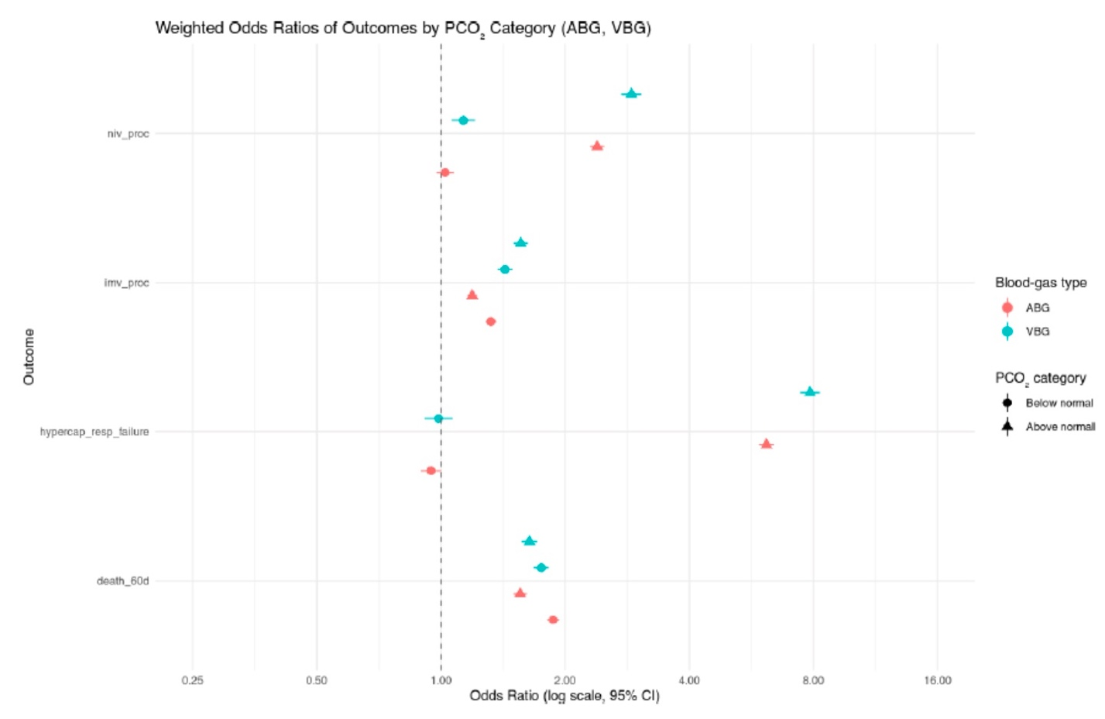

To further examine the continuous relationship between pCO₂ and clinical outcomes, restricted cubic spline models were constructed. Figure 2 presents the predicted probabilities for each outcome across pCO₂ values, stratified by ABG and VBG groups.

In Figure 2, there is a significant higher likelihood of receiving the four outcomes for the VBG group compared to ABG group as pCO₂ levels increase. Hypercapnic respiratory failure diagnosis and non-invasive ventilation had the largest gap in likelihood between the two groups. The predicted probability of the outcomes begin to increase at about 45 mmHg for ABG and 50 mmHg for VBG. Finally, mortality appeared unrelated to CO₂ status for the ABG group, suggesting that death in this cohort is more reflective of overall illness severity rather than hypercapnia itself.

Figure 2: Inverse Propensity Weighted Predicted Probability by ABG and VBG for the four outcomes. VBG group had higher likelihood of receiving the four outcomes compared to ABG group as pCO₂ levels increase. The gap was most significant for the hypercapnic respiratory failure diagnosis and non-invasive ventilation.

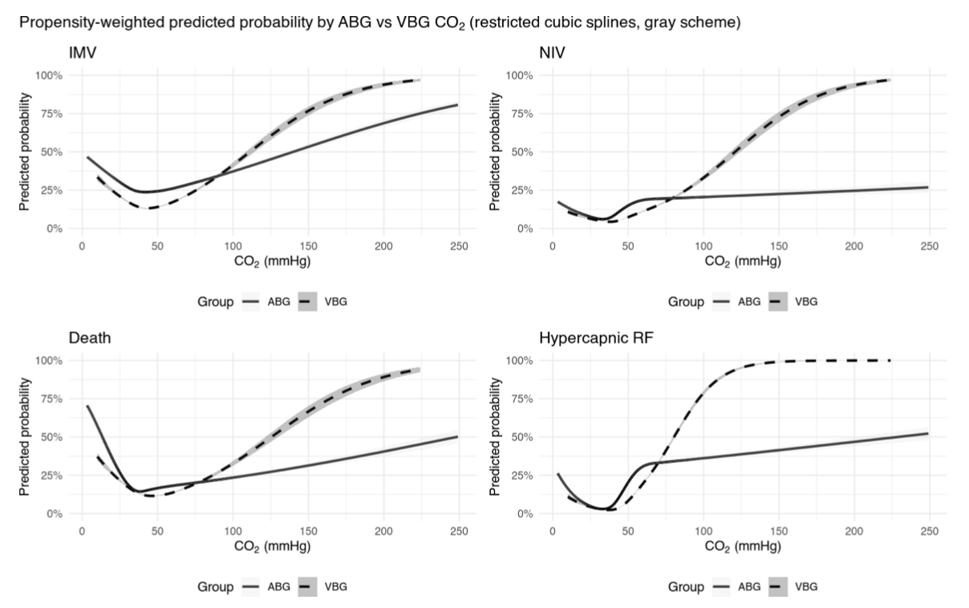

Discussion:

Overall, these findings suggest that venous and arterial blood gas measurements provide comparable clinical information in predicting key outcomes, including non-invasive ventilation, invasive mechanical ventilation, diagnosis of hypercapnic respiratory failure and 60-day mortality. The absence of significant differences between VBG and ABG groups indicate that VBG testing may be sufficient for guiding management decisions in many patients, potentially reducing the need for more invasive arterial sampling.

[ ] I’d add a quick paragraph about the other key findings – ie if any outcomes were particularly close, notable things about the shape of the splines, which factors correlated most with blood gasses.

Previous studies have shown that venous and arterial pCO₂ values are strongly correlated. However, the prior work has focused on diagnostic accuracy or correlation coefficients rather than clinical outcomes. Our study expands upon the current literature by linking arterial and venous blood gas measurements to meaningful clinical outcomes such as mechanical ventilation and mortality. Our results have broader implications for both clinical practice and healthy system policy. Despite widespread clinical use of VBGs to assess hypercapnia, formal diagnostic criteria, billing structures and device qualification requirements still rely on arterial confirmation. Aligning these frameworks with real-world practice could simplify workflows, reduce patient discomfort, and lower costs without comprising diagnostic accuracy. Expanding the acceptance of venous-based definitions may also enable more efficient outpatient follow-up and titration of non-invasive ventilation or supplemental oxygen therapy.

I think it might be good to have a paragraph that spells out exactly what we think our design supports, what the key assumptions are, and how deviations might change that. So we might say that our study supports a prognostic conclusion about the importance of each results, but is contingent on us correctly modeling who gets ABG vs VBG – undoubtedly some residual confounding related to things providers see but aren’t in the medical record, and that our results.. then dwell on the implications a bit more from the last paragraph.

Strength and Limitations

This study has several strengths. Its large, multi-institutional cohort enhances analytic flexibility and minimizes overfitting risk, allowing stable modeling of sampling and outcome relationships. The study design reflects real-world clinical practice by stratifying patients who underwent either ABG or VBG testing, providing insight into how hypercapnia is assessed and managed across different clinical contexts. The use of multivariable logistic regressions and inverse propensity weighting allowed for the adjustment of measured cofounders and provided a robust assessment of associations between hypercapnia and important clinical outcomes such as mechanical ventilation, non-invasive ventilation and 60-day mortality. Propensity scores were estimated using a machine learning method that accommodates non-linear relationships and missing data.

However, this study does have certain limitations. The retrospective design of this study eliminates casual inference and is at risk for confounders that bias results. Unmeasured variables such as provider practice style or illness severity may have influenced both the likelihood of testing and clinical outcomes. Since data was extracted from the electronic health record, misclassification or missing data in comorbidities, test results or outcomes is possible. This study relied on single blood gas measurements obtained on hospital day 1, which limits the ability of assess temporal changes in pCO₂ or the effect of repeated sampling over time.

[ ] might add the policy implication paragraph here (if not lumped into the one I suggested)

Further work is needed to confirm these findings in prospective studies. Pragmatic prospective cohort with protocolized testing omparing ABG versus VBG management could more directly establish causality and inform guidelines. Repeated measurements throughout a patient encounter as well would also better capture the relationship between changing pCO₂ values and outcomes. [ ] post-discharge management, as mentioned below. Additionally, subgroup analyses focusing on specific patient populations with certain comorbidities will further clarify whether VBGs are equally reliable as ABGs.

Conclusion:

In reweighted cohorts, VBG-identified hypercapnia showed similar prognostic associations to ABG for ventilatory support and mortality. VBG results were also similarly associated with subsequent diagnostic labeling, suggesting its use despite current formal criteria. This implies that broader acceptance of VBG-based definitions in billing and device qualification should be considered, pending external validation and associations with post-discharge management.

References:

1. Lacy ME, Saa L, Bruss Z, Noronha L. Things We Do for No ReasonTM: Arterial blood gas testing to screen for hypercarbic respiratory failure. J Hosp Med. 2025;20(9):1002-1004. doi:10.1002/jhm.70039
2. Davies MG, Wozniak DR, Quinnell TG, et al. Comparison of mathematically arterialised venous blood gas sampling with arterial, capillary, and venous sampling in adult patients with hypercapnic respiratory failure: a single-centre longitudinal cohort study. BMJ Open Respir Res. 2023;10(1):e001537. doi:10.1136/bmjresp-2022-001537
3. Ak A, Ogun CO, Bayir A, Kayis SA, Koylu R. Prediction of Arterial Blood Gas Values from Venous Blood Gas Values in Patients with Acute Exacerbation of Chronic Obstructive Pulmonary Disease. Tohoku J Exp Med. 2006;210(4):285-290. doi:10.1620/tjem.210.285
4. McKeever TM, Hearson G, Housley G, et al. Using venous blood gas analysis in the assessment of COPD exacerbations: a prospective cohort study. Thorax. 2016;71(3):210. doi:10.1136/thoraxjnl-2015-207573

Supplement:

Things like the propensity diagnostics could be included in the supplement.

Figure S1: Distribution of Inverse Propensity-Weighted Scores for ABG and VBG groups. Untested patients clustered near zero, while tested patients were skewed toward higher probabilities of being tested.

